|  |  |
| --- | --- |
| **Digital Forensics**  Diploma in CSF/IT  Year 2/3 (2022/23) Semester 4/6 | Week 7 |
| Tutorial 6 |
| **NTFS Analysis** | |

**OBJECTIVES**

After completing this topic, you should be able to

1. Perform Hexadecimal number addition without using calculator;
2. Perform forensic analysis on NTFS file system;
3. Explain the difference between different timestamps in MFT.

Q1: Perform addition on the hexadecimal numbers using Table 1.

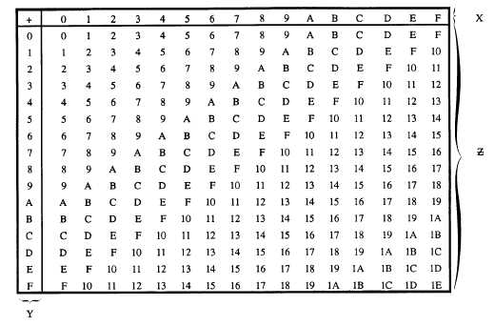

Figure 1: Hexadecimal Addition Table



|  |  |  |  |
| --- | --- | --- | --- |
|  | 4 | 5 | 616 |
| + | 7 | 8 | 416 |
|  | B | D | A |

|  |  |  |  |
| --- | --- | --- | --- |
|  | 7 | 8 | 416 |
| + | B | D | A16 |
| 1 | 3 | 5 | E |

|  |  |  |
| --- | --- | --- |
|  | 9 | 816 |
| + | 7 | 816 |
| 1 | 1 | 0 |

Q2. Figure 2-1 shows the MFT record of an NTFS file system.

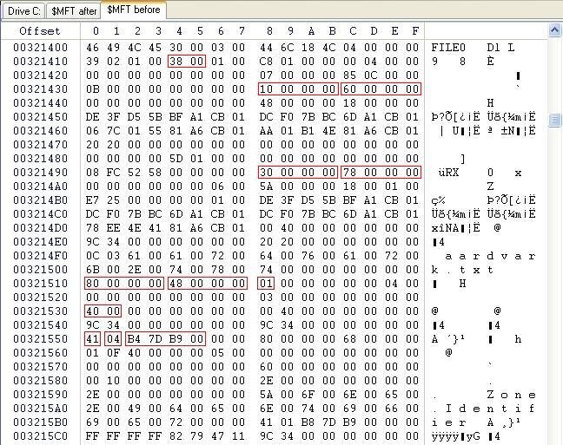

Figure 2-1: MFT File Record

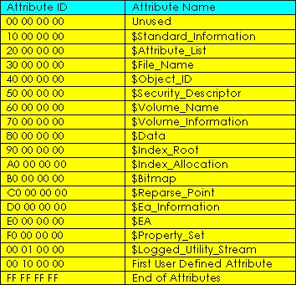

Figure 2-2: NTFS Attributes

Answer the following with reference to Figure 2-1 and 2-2. You may use Hex addition table or calculator to perform the addition.

1. What is the byte offset to the first attribute? 0x38 hex
2. What is the attribute name of this first attribute? 0x10 $Standard_Information

The next 4 bytes immediately after attribute type is the length (in bytes) of that attribute.

1. What is the length of first attribute? 0x60 hex
2. What is the byte offset of second attribute? 0x98 (0x38+0x60)
3. What is the attribute name of second attribute? 0x30 $File_Name
4. What is the name of the file in this entry? Aardvark.txt
5. What is the byte offset of the file content ($Data)? 0x110 (0x98 + 0x78)

Q3. (a) An investigator was examining a hard disk drive that was formatted with NTFS file system. Figure 3(a)-1 shows an entry/record in the Master File Table (MFT) and Figure 3(a)-2 and Figure 3(a)-3 show the list of NTFS attributes and Attribute header respectively.

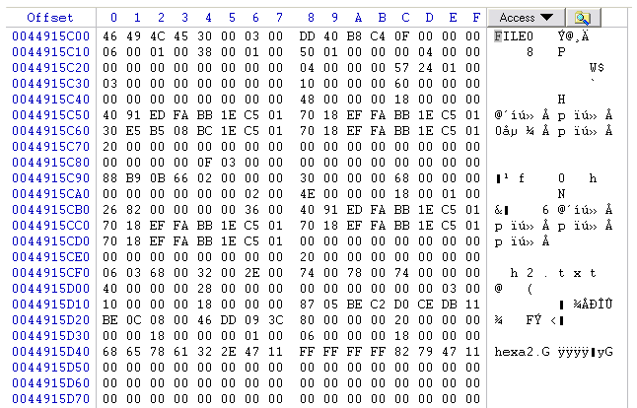

**Byte offset 0x38**

Figure 3(a)-1: An Entry/Record in Master File Table



Figure 3(a)-2: NTFS Attributes

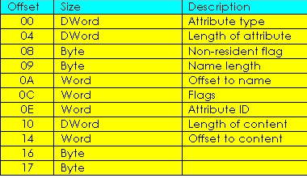

Figure 3(a)-3: Attribute Header

Given that the byte offset to the first attribute is **0x38** (hex), based on Figure 3(a)-1 to 3(a)-3 above, answer the following questions:

* 1. How do you tell if this MFT entry is a valid/usable entry? What represents an unusable entry?

If the first 4 bytes of the MFT shows FILE, it is a valid entry, BAAD would signify invalid

* 1. What is the name of the file/folder represented by this entry?

h2.txt

* 1. Complete the following table for this MFT entry.

|  |  |
| --- | --- |
|  | Attribute Name |
| 1st Attribute | $Standard_Information 0x38 |
| 2nd Attribute | $File_Name 0x98 |
| 3rd Attribute | $Object_ID 0x100 |
| 4th Attribute | $Data 128 |

* 1. Is the 4th attribute a Resident or Non-resident attribute? Explain.

The non-resident flag for 4th attribute is ‘00’, as shown at byte offset 0x130 meaning it is a resident attribute

* 1. Which location on the hard disk can you find the content of this file? Explain.

The content of this file can be found in the MFT, as $Data shows that this is resident file

(b) Briefly explain how Windows operating system stores files of the following sizes in disk drive configured with NTFS with respect to the Master File Table (MFT). In your answers, explain how the Non-Resident flag is set.

* 1. 100 Bytes
  2. 5 Kbytes

Q4. Where is the Volume Boot Record (VBR) located in the NTFS partition?

Logical sector 0 first 16 sectors of the active partition

Q5. Both $Standard_Information and $File_Name contain MACE timestamps. Explain the difference between the timestamps found in these 2 attributes.

$Standard_Information Timestamps do not contain the entry modified timestamps and can be found through file properities

- End -